Design Report

Assignment 2

https://github.com/xiehao123/javaee-second-work.git

# 项目数据库设计

## 实体关系图

项目现阶段，主要包含以下三个数据库表，实体之间的关系如下图所示:

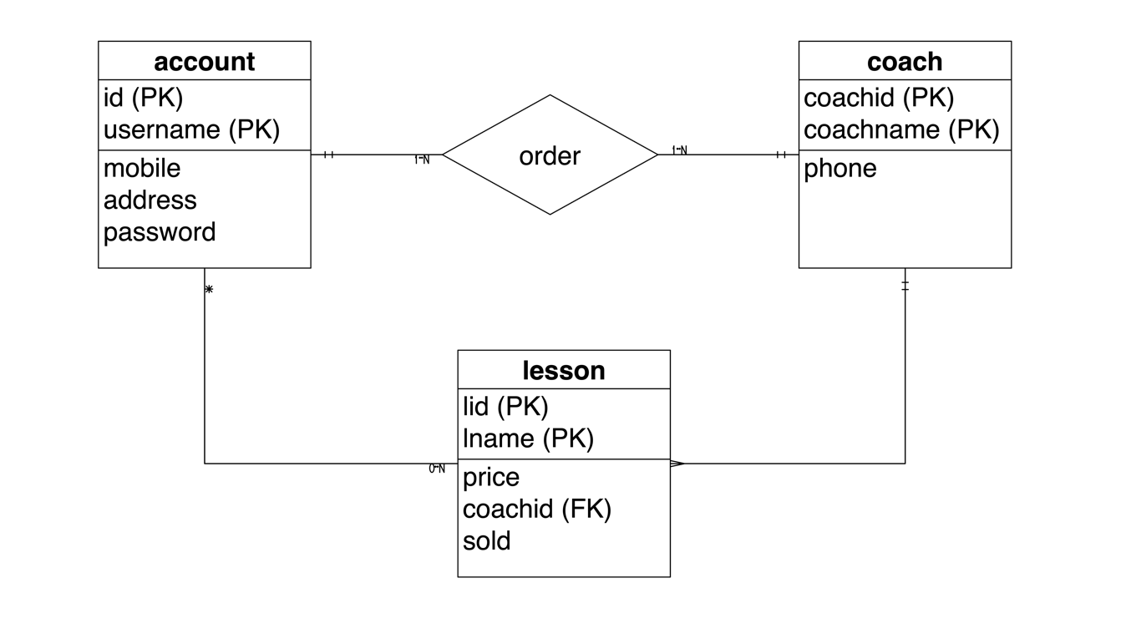

图 2 实体关系图

一个用户可以上多个课程，每个教练也可以同时教授多个课程。而一个用户也选择多个教练学习，而两者之间是通过用户购买课程生成订单进行的。

## 数据库表格设计

1. account表

|  |  |  |  |  |
| --- | --- | --- | --- | --- |
| Id | username | mobile | address | Password |
| integer | string | integer | string | sting |

1. coach 表

|  |  |  |
| --- | --- | --- |
| id | coachname | phone |
| integer | string | integer |

1. lesson 表

|  |  |  |  |  |
| --- | --- | --- | --- | --- |
| Lid | lname | price | coachid | sold |
| integer | string | double | intger | integer |

# 部分RESTFUL API

## **Restful API 获取所有用户列表**

Method: GET

Request URL: <http://localhost:8080/v1/get_users>

Demo:

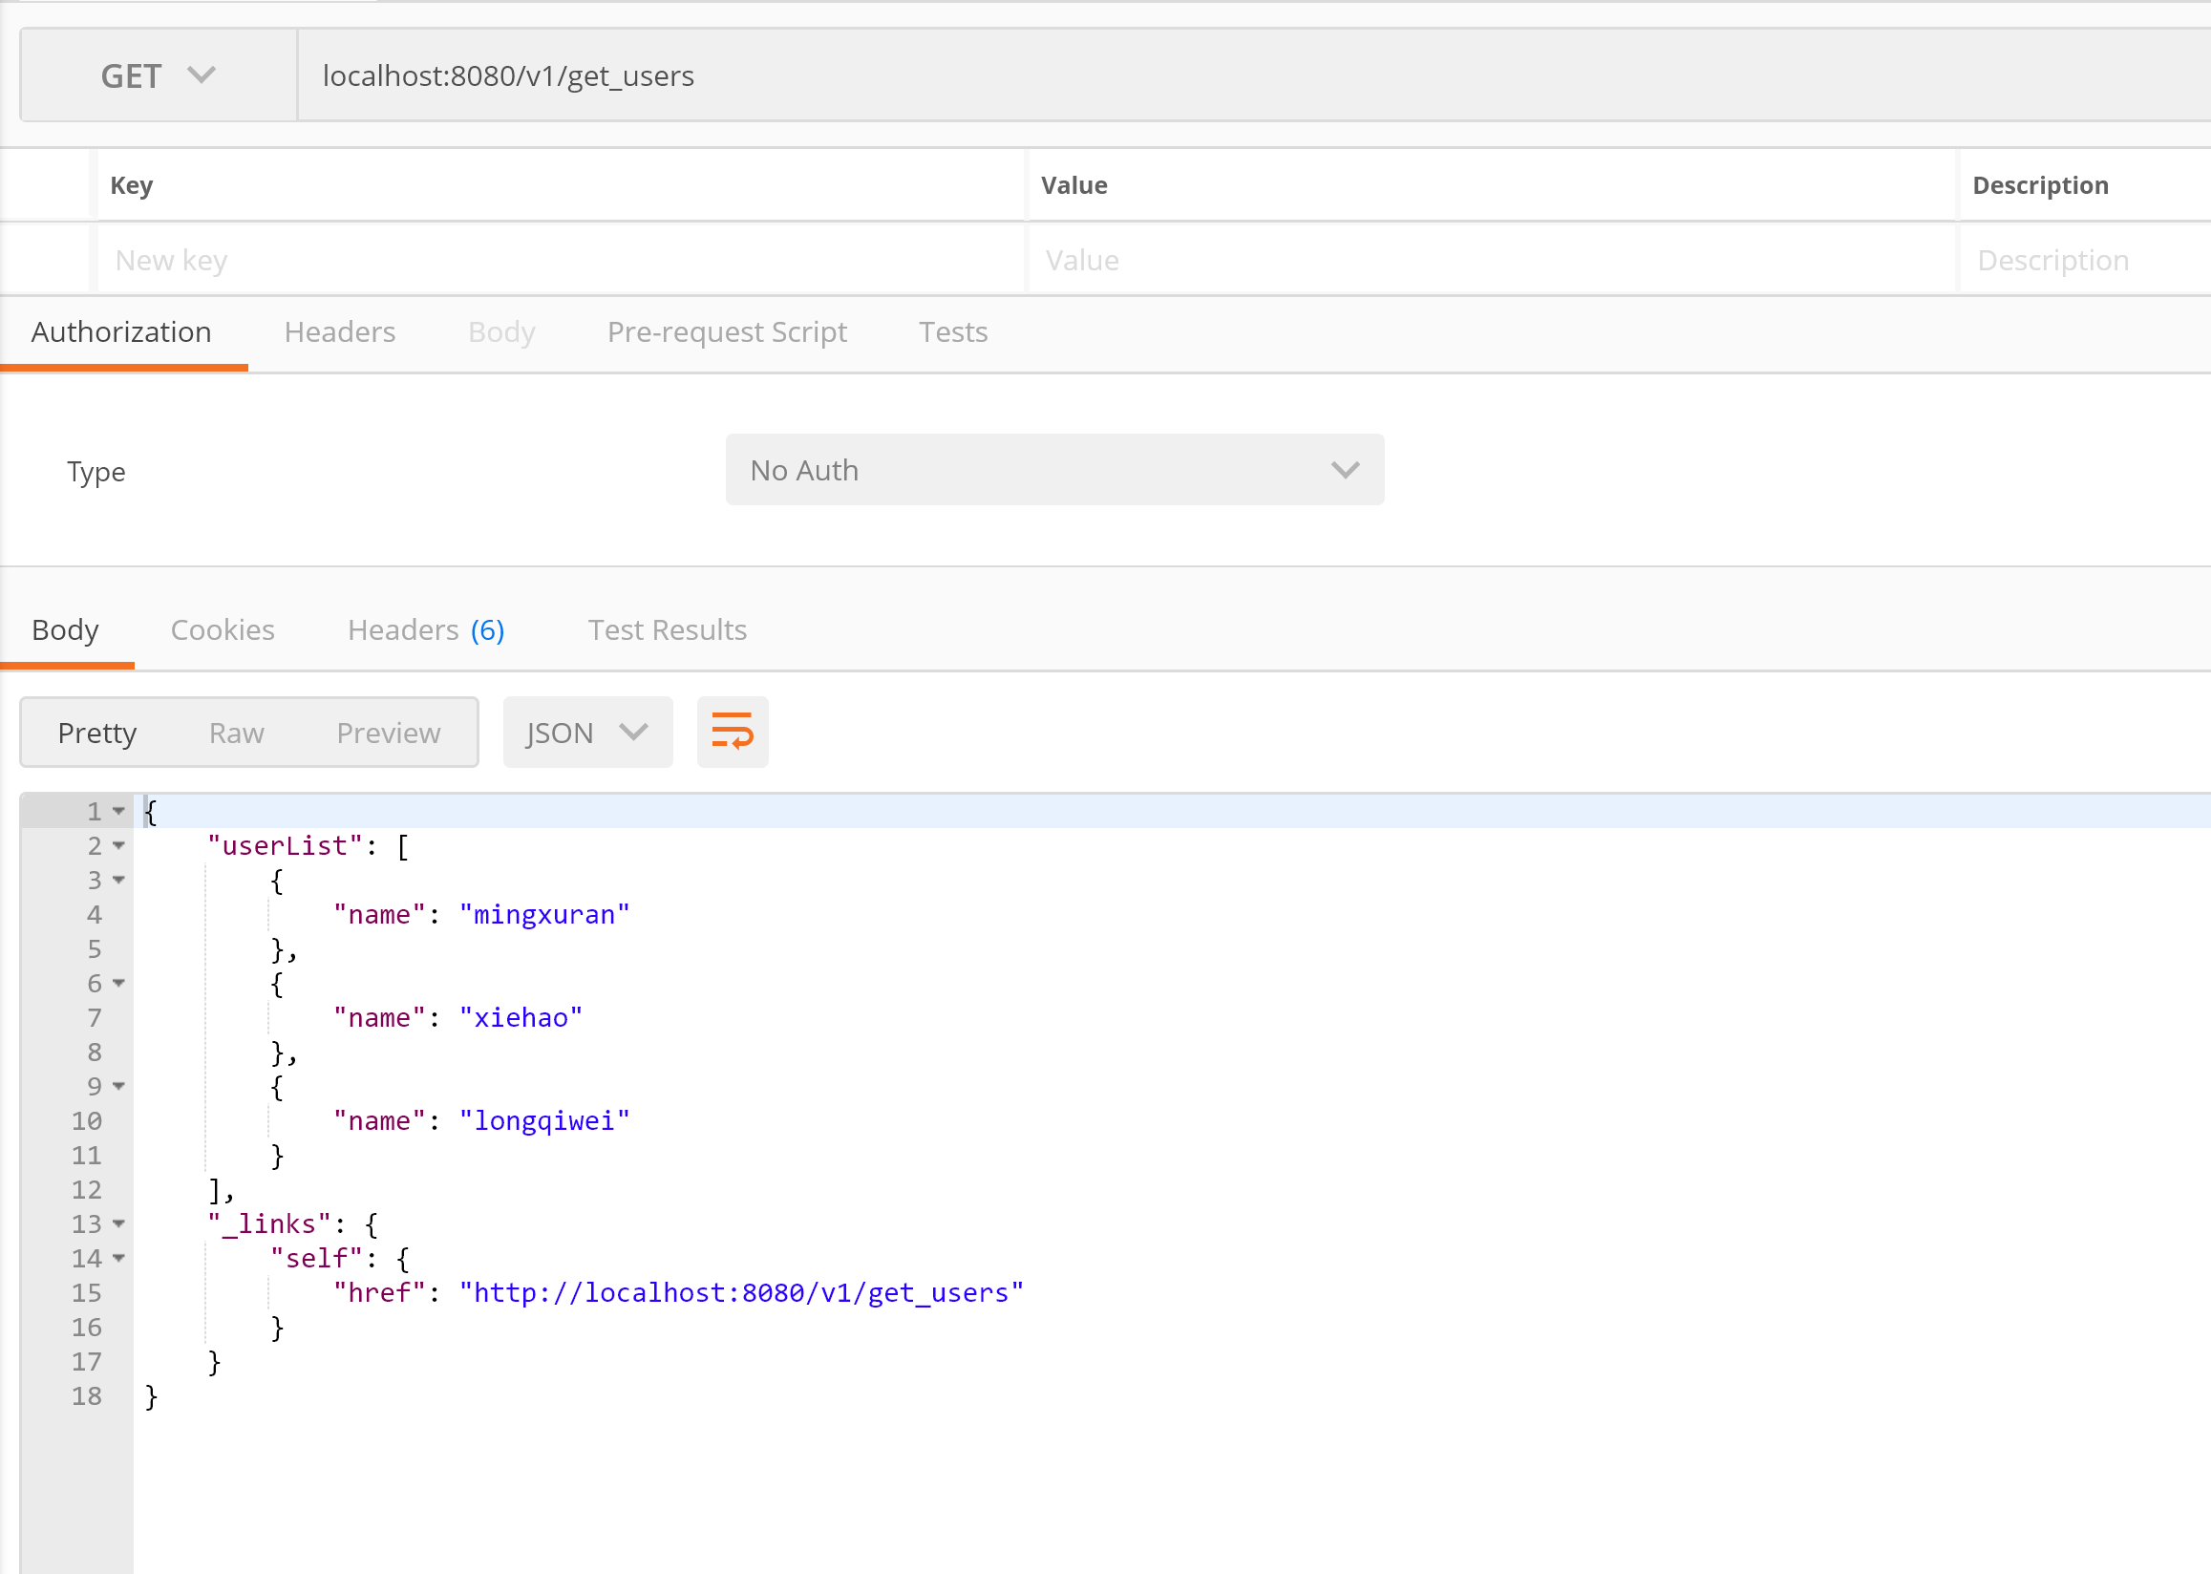

## **Restful API 添加一个用户**

Method: POST

Request URL: <http://localhost:8080/v1/add_user>

Params:

name

password

Demo:

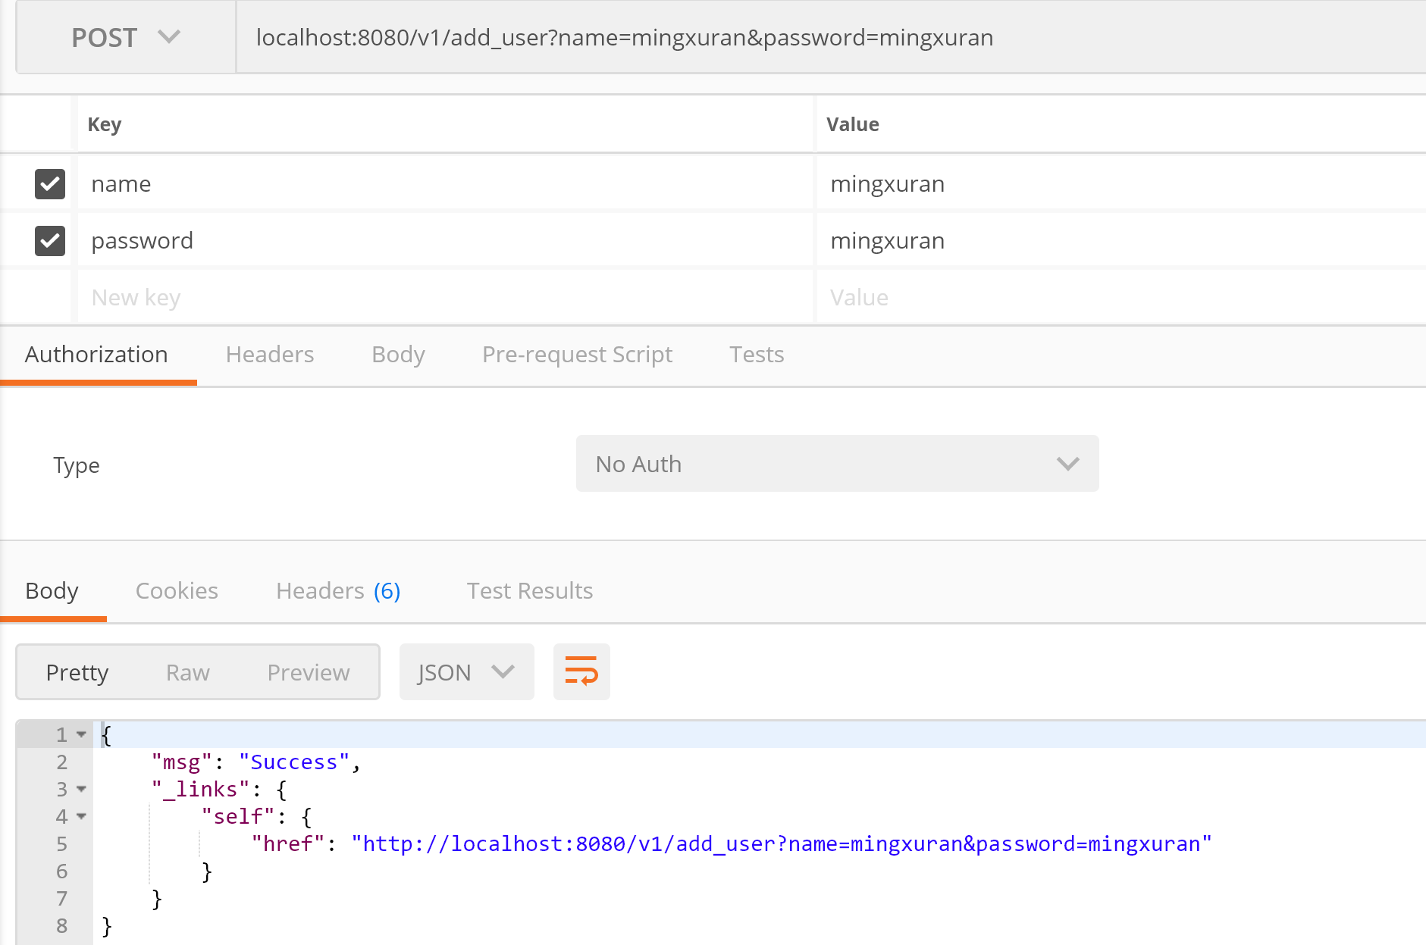

## **Restful API 通过用户名删除一个用户**

Method: POST

Request URL: [http://localhost:8080/v1/del_user_by_name](http://localhost:8080/v1/del_user_by_namer)

Params:

name

Demo:

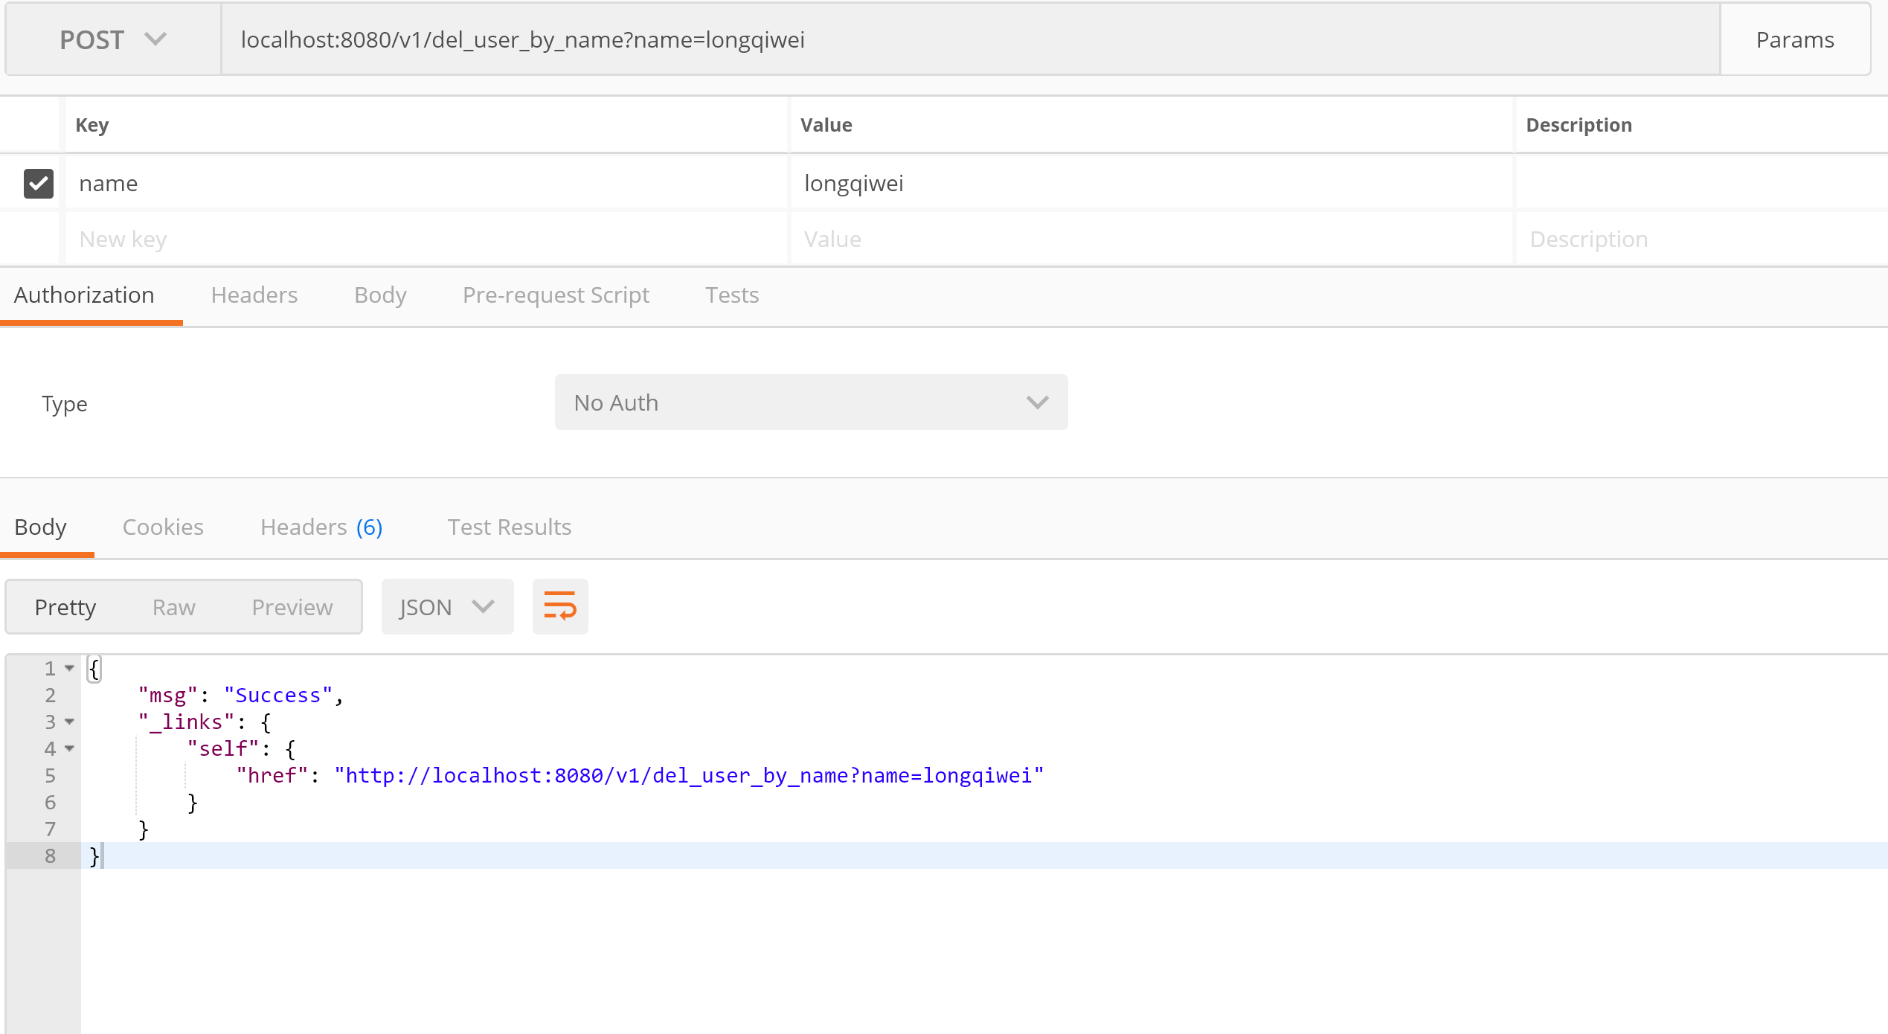

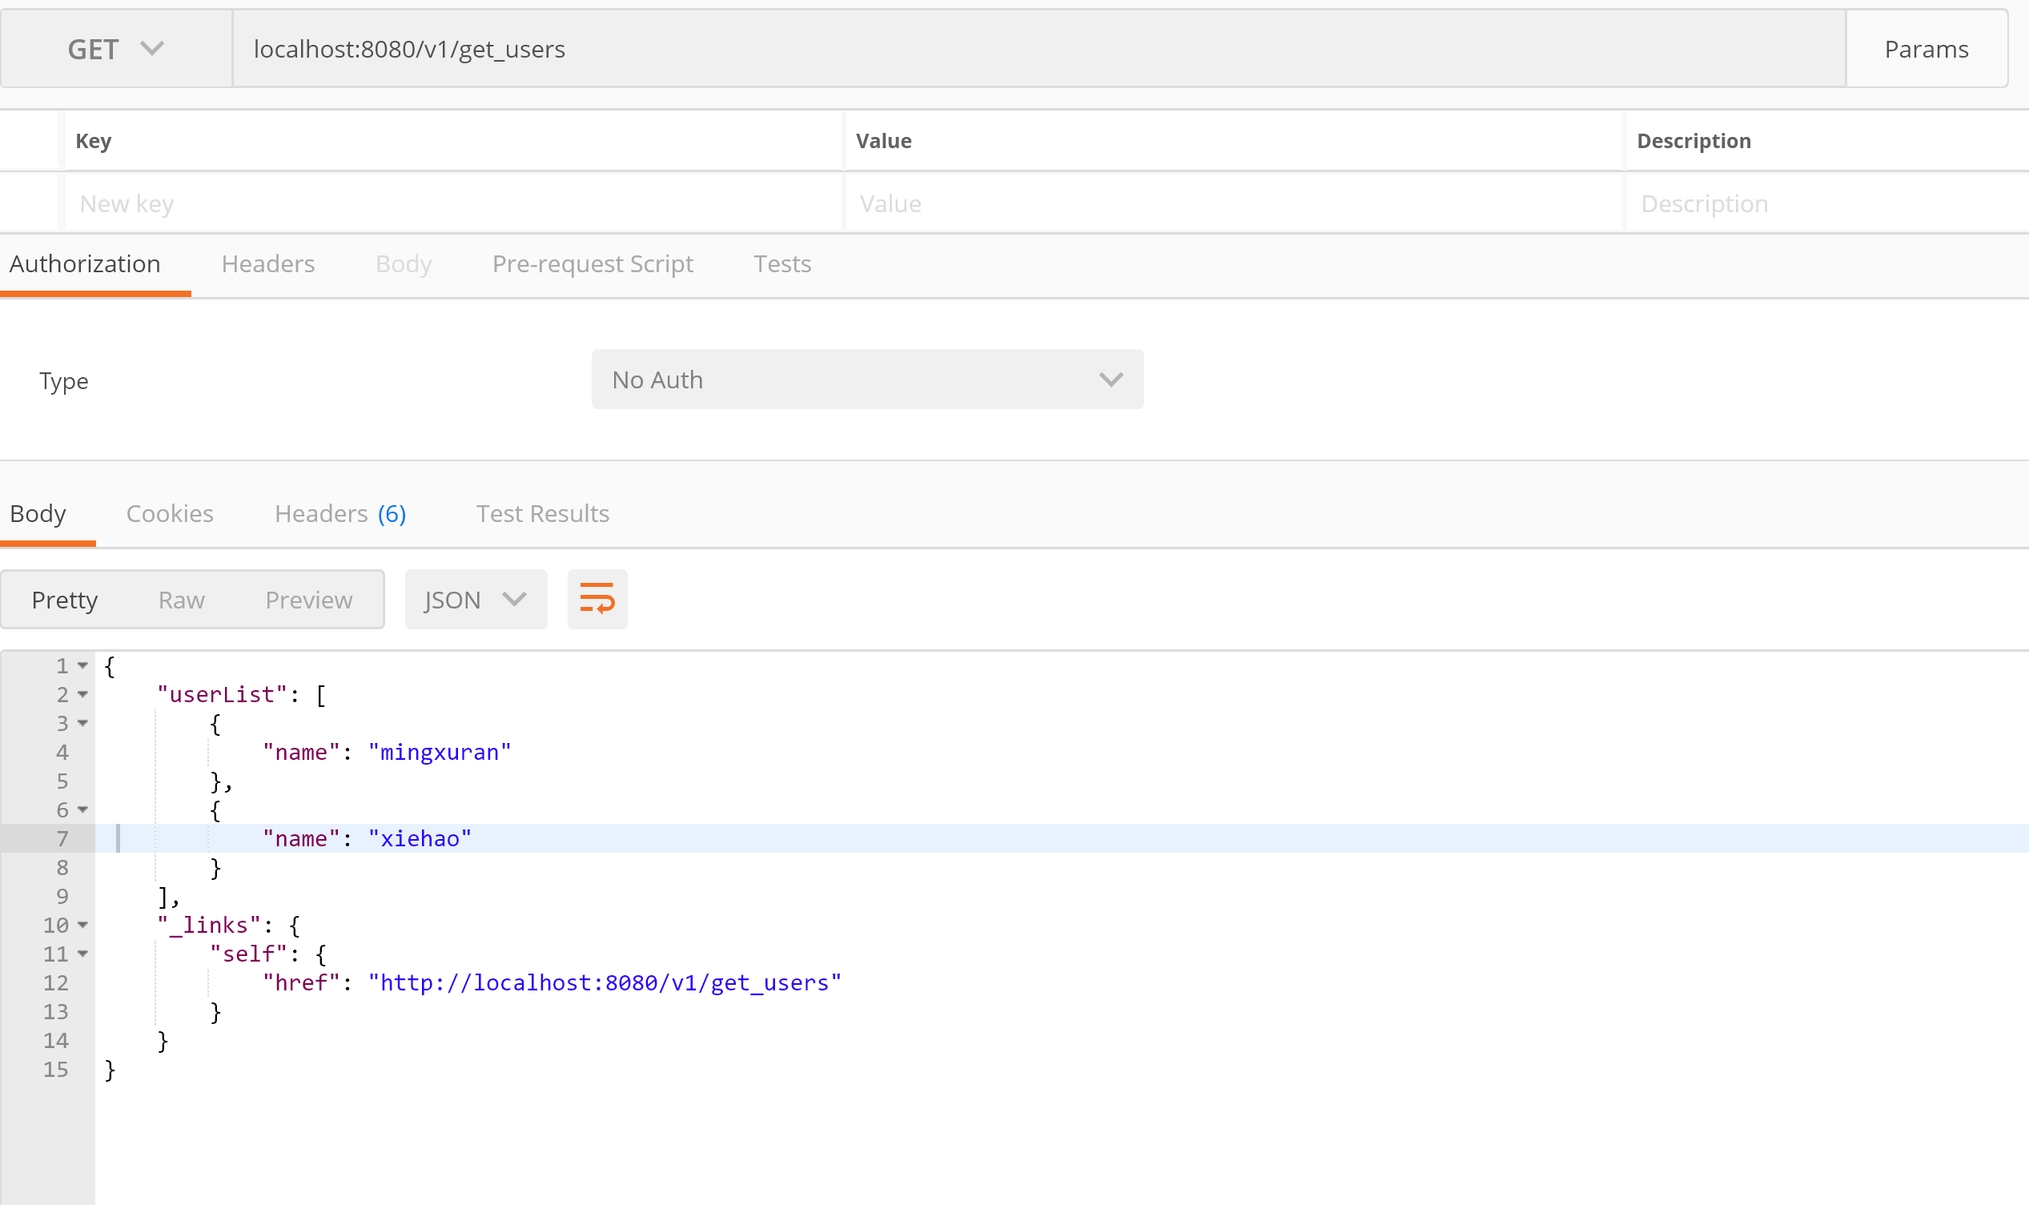

## **Restful API 添加一个教练**

Method: POST

Request URL: <http://localhost:8080/v1/add_trainer>

Params:

name

phone

Demo:

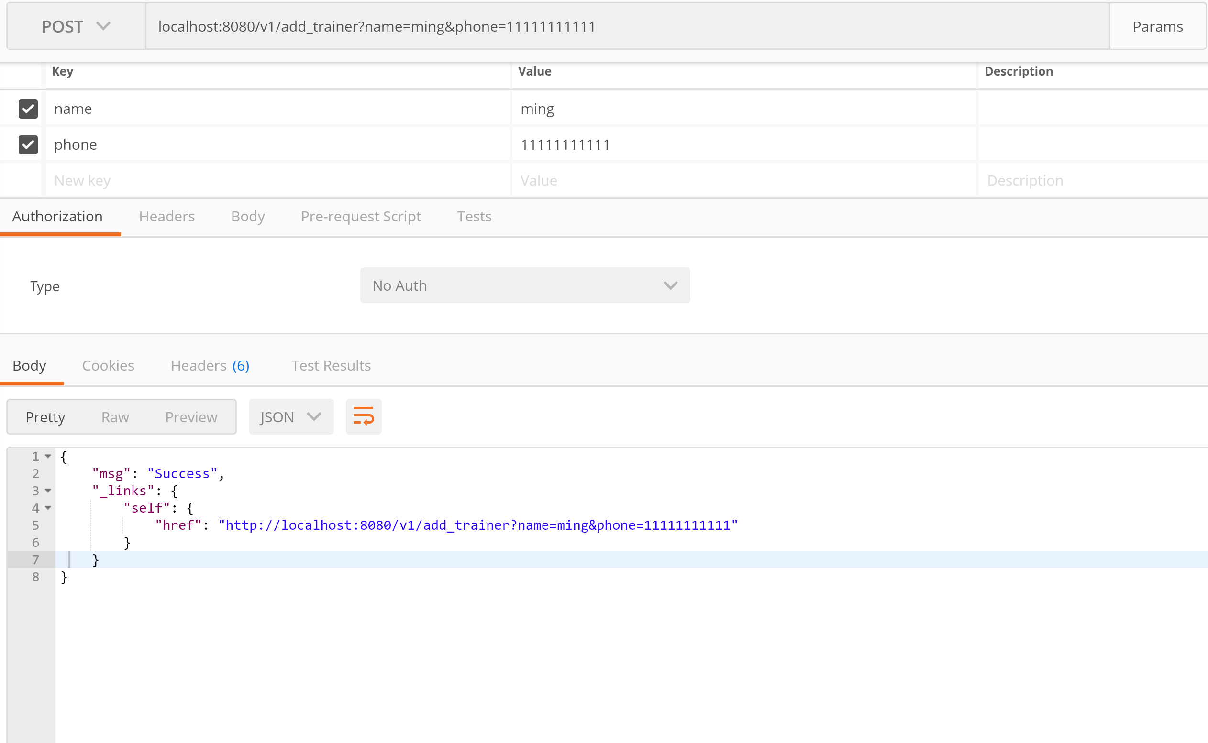

## **Restful API 获取所有教练列表**

Method: GET

Request URL: <http://localhost:8080/v1/get_trainers>

Params:

name

phone

Demo:

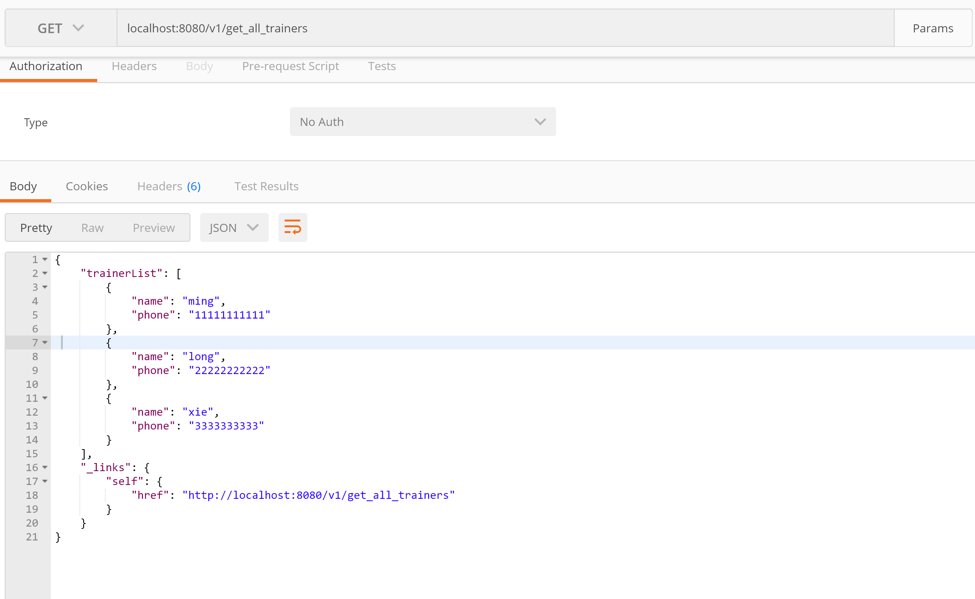

## **Restful API 通过电话删除一个教练**

Method: POST

Request URL: <http://localhost:8080/v1/del_trainer_by_phone>

Params:

phone

Demo:

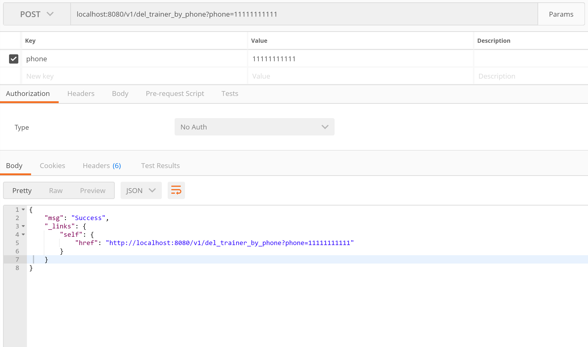

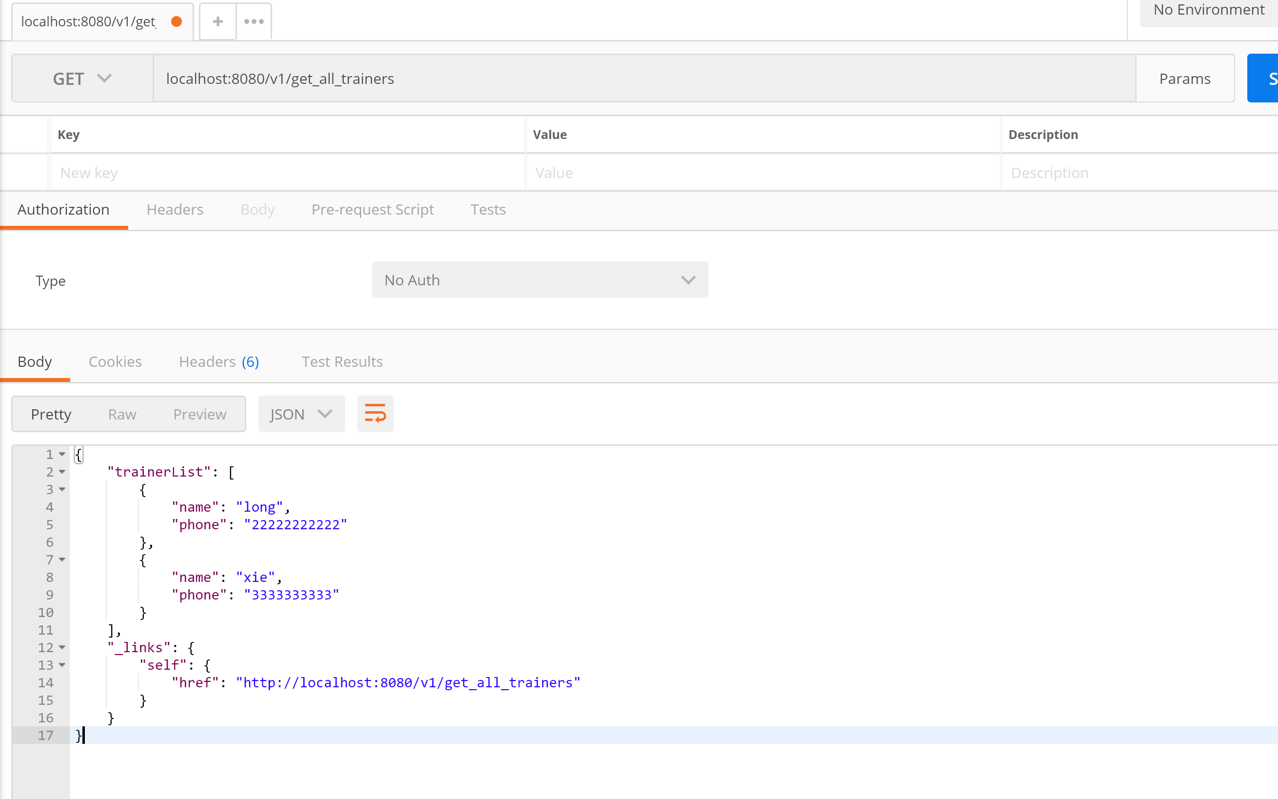

# Oauth2



# RateLimit

Framework:

spring-cloud-zuul-ratelimit

Enable Zuul Proxy

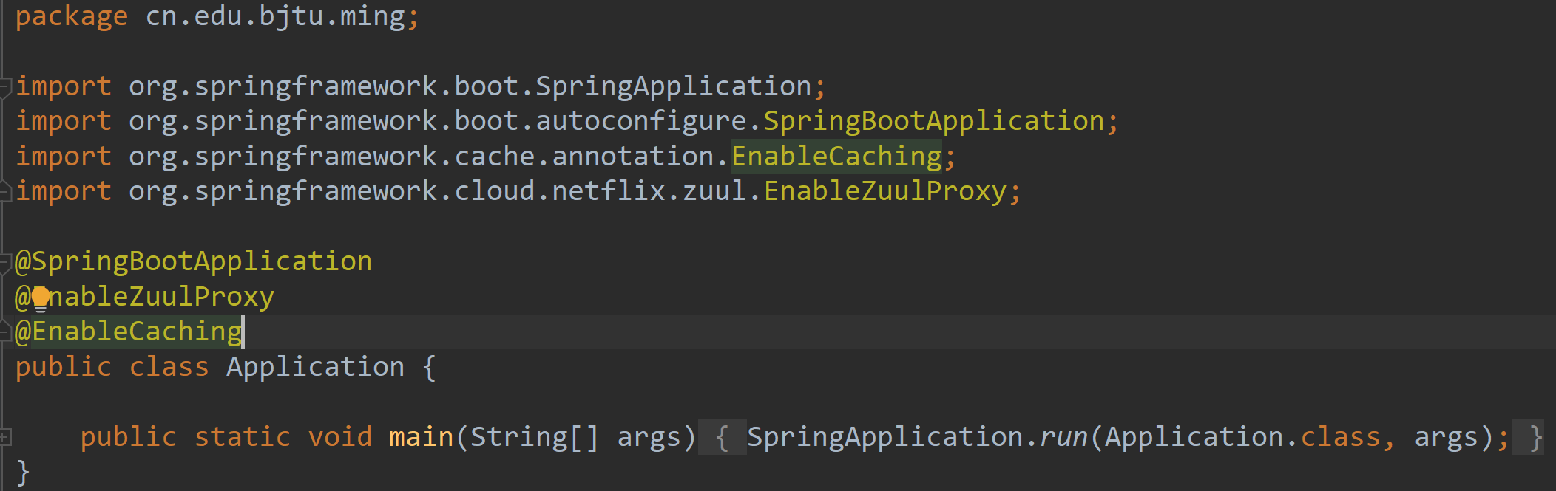

Config Zuul in application.yml

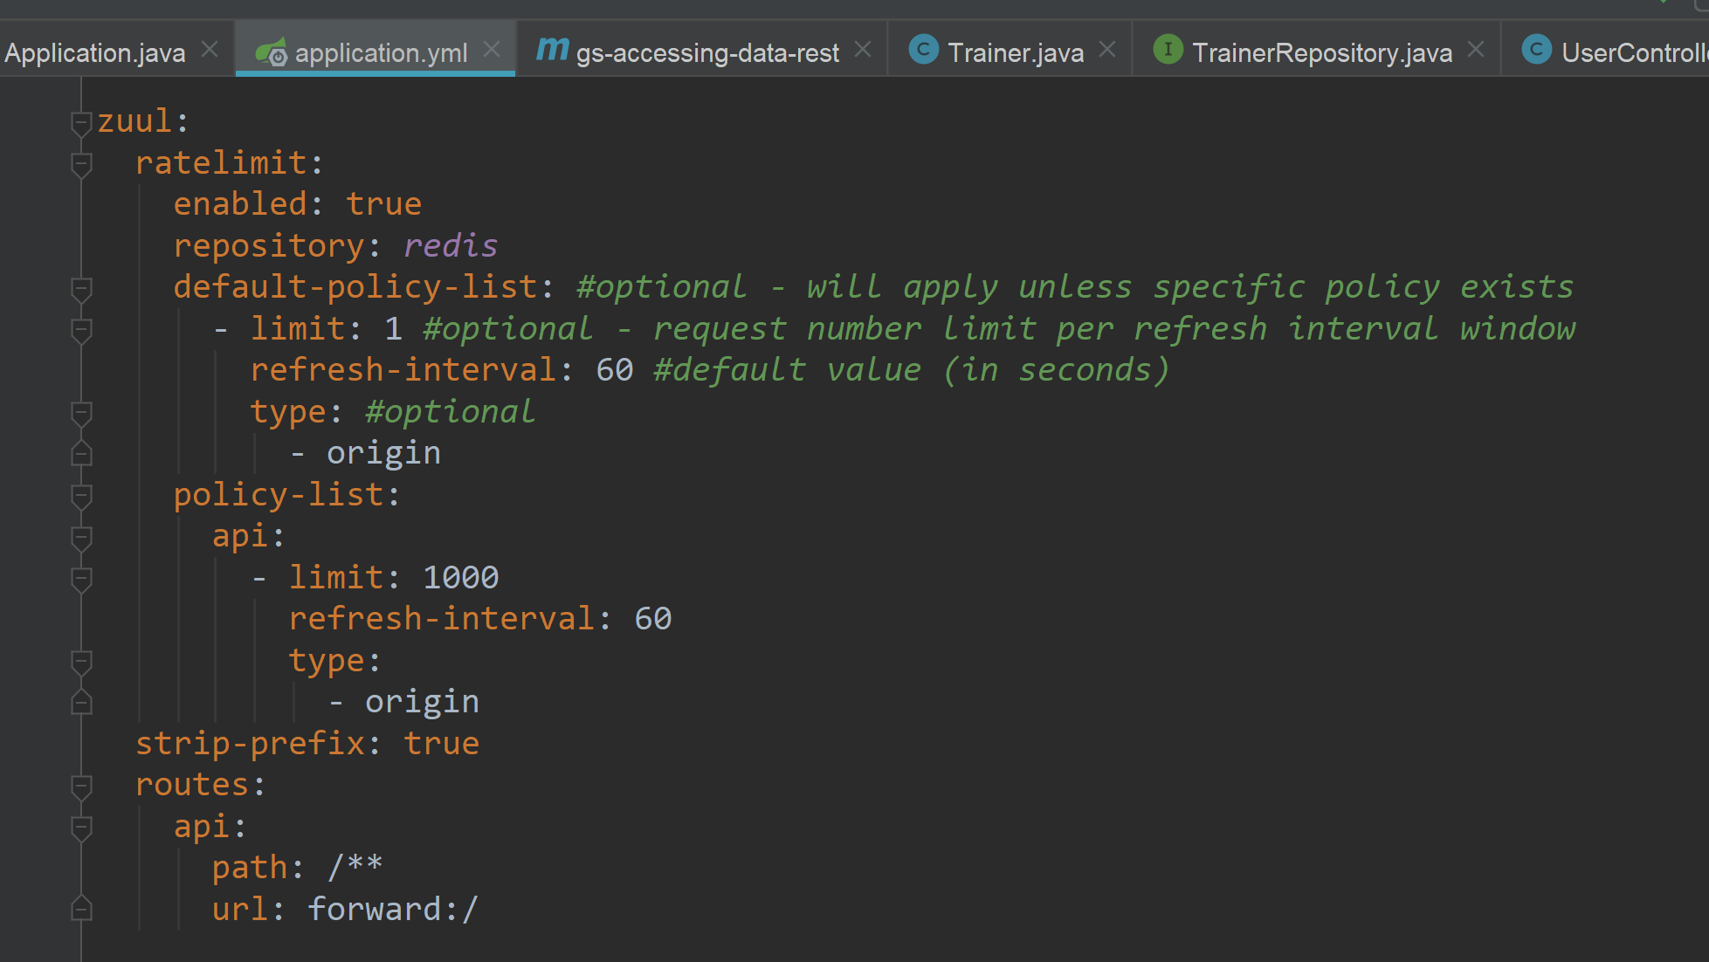

From the headers we can say rate was limited

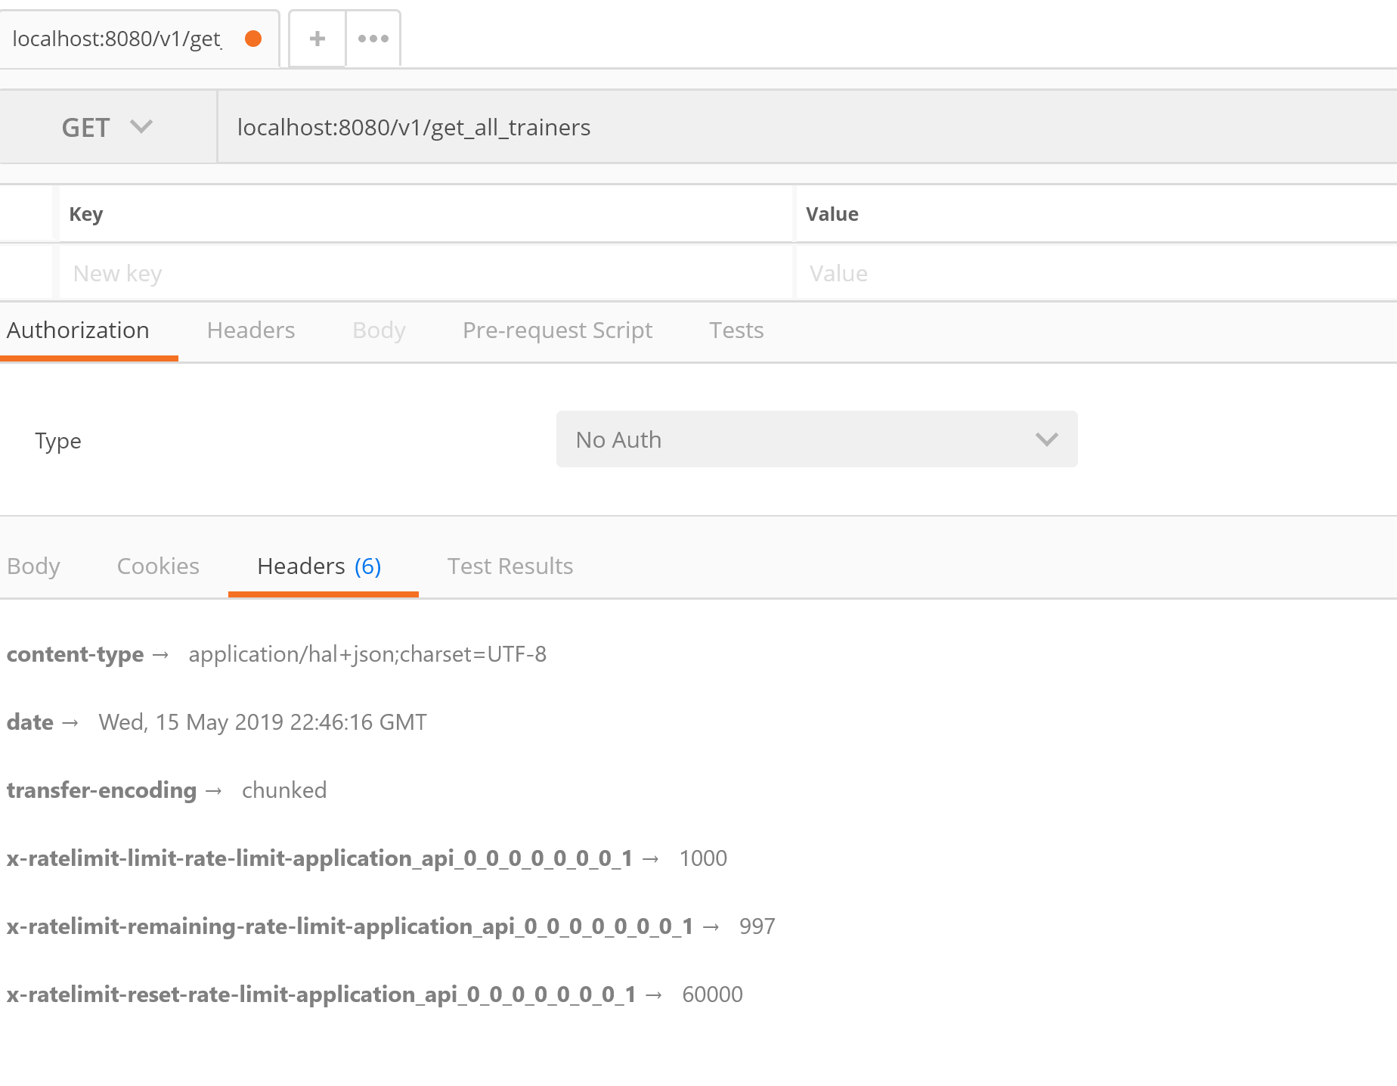

# Others

## Swagger

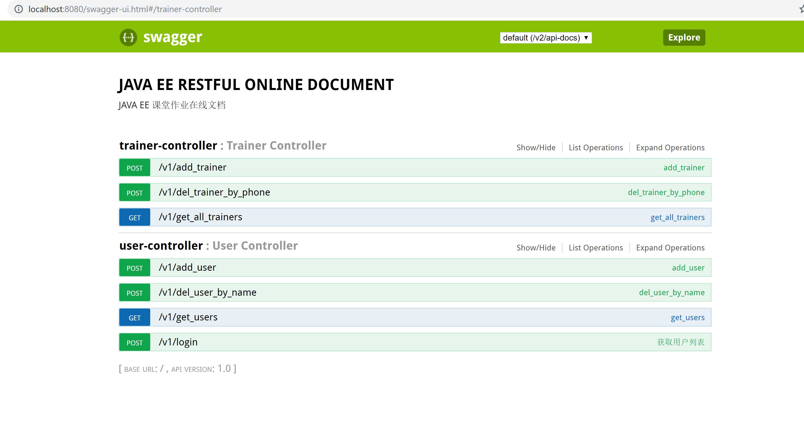

## API pagination

Framework:

PageHelper

Demo:

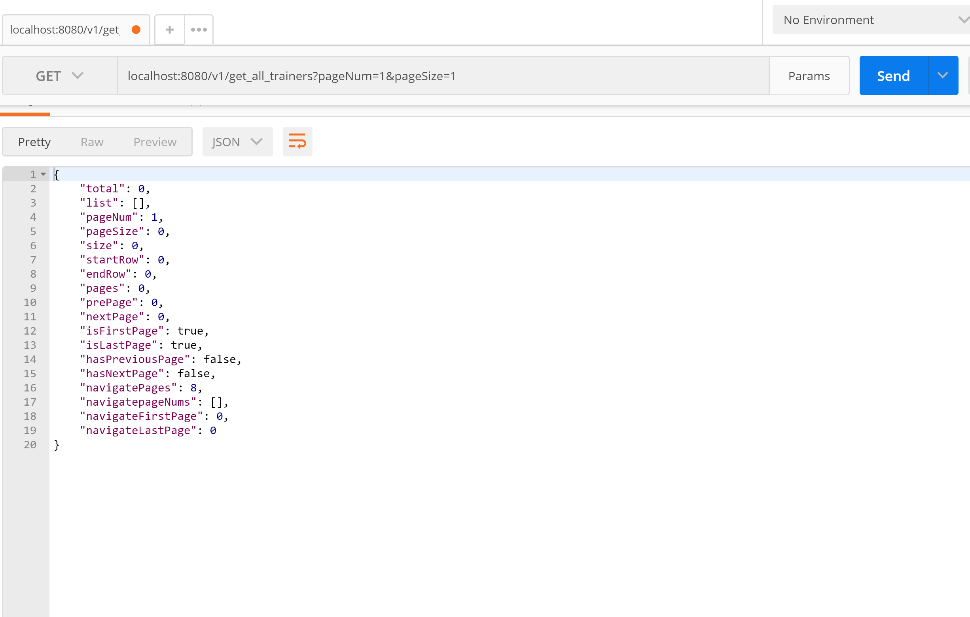

## Cache

We enabled Cache and cache GET methods in Dao

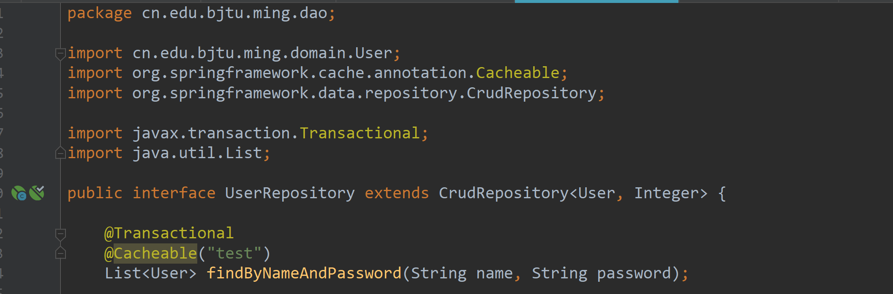

## Hateoas

